**M.Sc. I.T. Semester II**

**BIG DATA ANALYTICS**

**List of Practical**

|  |  |
| --- | --- |
| **Practical No.** | **Details** |
| **1** | **Install, configure and run Hadoop and HDFS and explore HDFS.** |
| **2** | **Implement word count / frequency programs using MapReduce** |
| **3** | **Implement an application that stores big data in Hbase/MongoDB and manipulate it using R/Python** |
| **4** | **Implement the program in practical 4 using Pig.** |
| **5** | **Configure the Hive and implement the application in Hive.** |
| **6** | **Implement the following:** |
| **A.** | **Implement Decision tree classification techniques** |
| **B.** | **Implement SVM classification techniques** |
| **7** | **Solve the following:** |
| **A.** | **REGRESSION MODEL Import a data from web storage. Name the dataset and now do Logistic Regression to find out relation between variables that are affecting the admission of a student in an institute based on his or her GRE score, GPA obtained and rank of the student. Also check the model is fit or not. require (foreign), require(MASS).** |
| **B.** | **MULTIPLE REGRESSION MODEL Apply multiple regressions, if data have a continuous independent variable. Apply on above dataset.** |
| **8** | **Solve the Following:** |
| **A.** | **CLASSIFICATION MODEL a. Install relevant package for classification. b. Choose classifier for classification problem. c. Evaluate the performance of classifier.** |
| **B.** | **CLUSTERING MODEL a. Clustering algorithms for unsupervised classification. b. Plot the cluster data using R visualizations.** |

**PRACTICAL 1**

Hadoop Installation

**Aim:**

Install, configure and run Hadoop and HDFS and explore HDFS on Windows

**Code:**

**Steps to Install Hadoop**

1. Install Java JDK 1.8
2. Download Hadoop and extract and place under C drive
3. Set Path in Environment Variables
4. Config files under Hadoop directory
5. Create folder datanode and namenode under data directory
6. Edit HDFS and YARN files
7. Set Java Home environment in Hadoop environment
8. Setup Complete. Test by executing start-all.cmd

**There are two ways to install Hadoop, i.e.**

1. Single node
2. Multi node

Here, we use multi node cluster.

1. **Install Java**
2. – Java JDK Link to download

<https://www.oracle.com/java/technologies/javase-jdk8-downloads.html>

1. – extract and install Java in C:\Java
2. – open cmd and type -> javac -version

1. **Download Hadoop**

<https://www.apache.org/dyn/closer.cgi/hadoop/common/hadoop-3.3.0/hadoop-3.3.0.tar.gz>

* right click .rar.gz file -> show more options -> 7-zip->and extract to C:\Hadoop-3.3.0\

1. **Set the path JAVA_HOME Environment variable**
2. **Set the path HADOOP_HOME Environment variable**

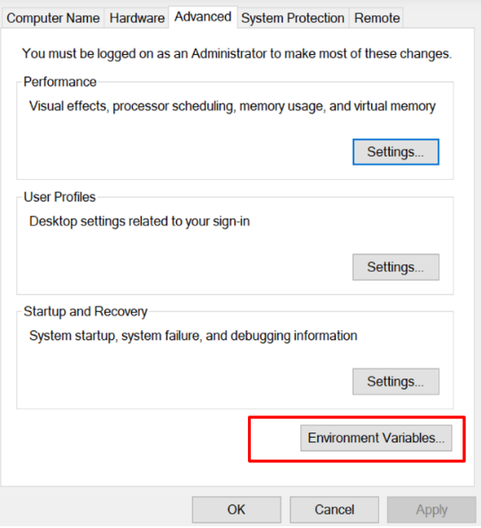

Click on **New to both user variables and system variables.**

**

Click Ok, Ok, Ok.

1. **Configurations**

**Edit file C:/Hadoop-3.3.0/etc/hadoop/core-site.xml,**

paste the xml code in folder and save

**======================================================**

<configuration>

<property>

<name>fs.defaultFS</name>

<value>hdfs://localhost:9000</value>

</property>

</configuration>

**======================================================**

**Rename “mapred-site.xml.template” to “mapred-site.xml” and edit this file C:/Hadoop-3.3.0/etc/hadoop/mapred-site.xml, paste xml code and save this file.**

**======================================================**

<configuration>

<property>

<name>mapreduce.framework.name</name>

<value>yarn</value>

</property>

</configuration>

**======================================================**

**Create folder “data” under “C:\Hadoop-3.3.0”**

**Create folder “datanode” under “C:\Hadoop-3.3.0\data”**

**Create folder “namenode” under “C:\Hadoop-3.3.0\data”**

**======================================================**

**Edit file C:\Hadoop-3.3.0/etc/hadoop/hdfs-site.xml,**

**paste xml code and save this file.**

<configuration>

<property>

<name>dfs.replication</name>

<value>1</value>

</property>

<property>

<name>dfs.namenode.name.dir</name>

<value>/hadoop-3.3.0/data/namenode</value>

</property>

<property>

<name>dfs.datanode.data.dir</name>

<value>/hadoop-3.3.0/data/datanode</value>

</property>

</configuration>

**======================================================**

**Edit file C:/Hadoop-3.3.0/etc/hadoop/yarn-site.xml,**

**paste xml code and save this file.**

<configuration>

<property>

<name>yarn.nodemanager.aux-services</name>

<value>mapreduce_shuffle</value>

</property>

<property>

<name>yarn.nodemanager.auxservices.mapreduce.shuffle.class</name>

<value>org.apache.hadoop.mapred.ShuffleHandler</value>

</property>

<property>

<name>yarn.resourcemanager.address</name>

<value>127.0.0.1:8032</value>

</property>

<property>

<name>yarn.resourcemanager.scheduler.address</name>

<value>127.0.0.1:8030</value>

</property>

<property>

<name>yarn.resourcemanager.resource-tracker.address</name>

<value>127.0.0.1:8031</value>

</property>

</configuration>

**======================================================**

1. **Edit file C:/Hadoop-3.3.0/etc/hadoop/hadoop-env.cmd**

Find “JAVA_HOME=%JAVA_HOME%” and replace it as

set JAVA_HOME="C:\Java\jdk1.8.0_361"

**======================================================**

1. **Download “redistributable” package**

**Download and run VC_redist.x64.exe**

This is a “redistributable” package of the Visual C runtime code for 64-bit applications, from Microsoft. It contains certain shared code that every application written with Visual C expects to have available on the Windows computer it runs on.

1. **Hadoop Configurations**

**Download bin folder from**

[**https://github.com/s911415/apache-hadoop-3.1.0-winutils**](https://github.com/s911415/apache-hadoop-3.1.0-winutils)

**– Copy the bin folder to c:\hadoop-3.3.0. Replace the existing bin folder.**

1. **copy "hadoop-yarn-server-timelineservice-3.0.3.jar" from ~\hadoop-3.0.3\share\hadoop\yarn\timelineservice to ~\hadoop-3.0.3\share\hadoop\yarn folder.**
2. **Format the NameNode**

**– Open cmd ‘Run as Administrator’ and type command “hdfs namenode –format”**

**11. Testing**

**– Open cmd ‘Run as Administrator’ and change directory to C:\Hadoop-3.3.0\sbin**

**– type start-all.cmd**

**OR**

**- type start-dfs.cmd**

**– type start-yarn.cmd**

**– You will get 4 more running threads for Datanode, namenode, resouce manager and node manager**

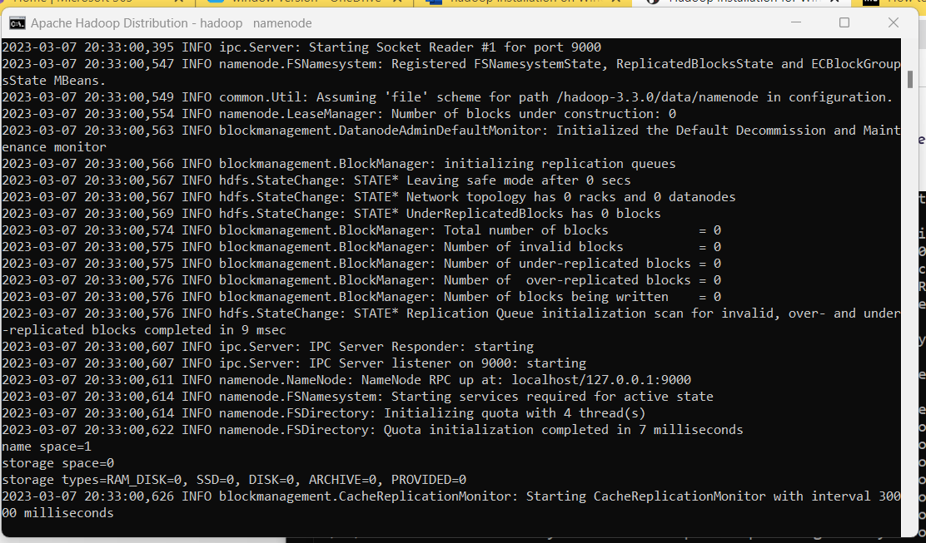

**Output:**

12. Type JPS command to start-all.cmd command prompt, you will get following output.

13. Run <http://localhost:9870/> from any browser

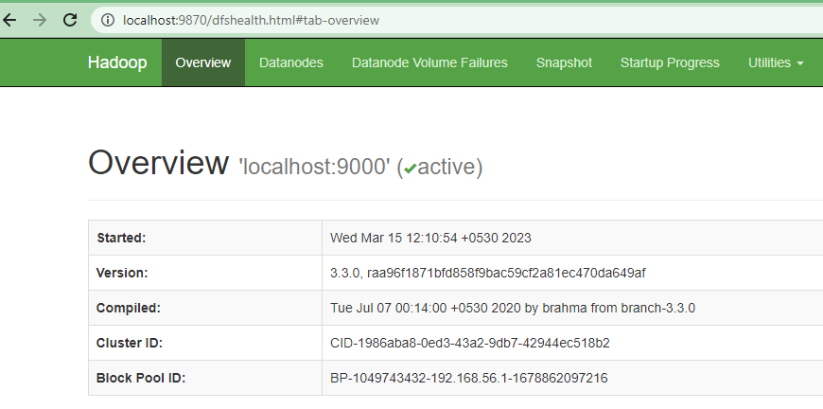

**PRACTICAL 2**

MapReduce Implementation

**Aim:**

Implement word count / frequency programs using MapReduce.

**Steps:**

C:\hadoop-3.3.0\sbin>start-dfs.cmd

C:\hadoop-3.3.0\sbin>start-yarn.cmd

Open a command prompt as administrator and run the following command to create an input and output folder on the Hadoop file system, to which we will be moving the sample.txt file for our analysis.

C:\hadoop-3.3.0\bin>cd\

 C:\>hadoop dfsadmin -safemode leave

DEPRECATED: Use of this script to execute hdfs command is deprecated.

Instead use the hdfs command for it.

Safe mode is OFF

C:\>hadoop fs -mkdir /input_dir

Check it by giving the following URL at browser

<http://localhost:9870>

Utilities -> browse the file system

Copy the input text file named input_file.txt in the input directory (input_dir)of HDFS.

Make a file in c:\input_file.txt and write following content in it.

Hadoop Window version is easy compared to Ubuntu version

Now apply the following command at c:\>

C:\> hadoop fs -put C:/input_file.txt /input_dir

**Verify input_file.txt available in HDFS input directory (input_dir).**

C:\>Hadoop fs -ls /input_dir/

**Verify content of the copied file**

C:\>hadoop dfs -cat /input_dir/input_file.txt

You can see the file content displayed on the CMD.

Run MapReduceClient.jar and also provide input and out directories.

C:\>hadoop jar C:/hadoop-3.3.0/share/hadoop/mapreduce/hadoop-mapreduce-examples-3.3.0.jar wordcount /input_dir /output_dir

In case, there is some error in executing then copy the file MapReduceClient.jar in C:\ and run the program with the jar file using existing MapReduceClient.jar file as:

C:\> hadoop jar C:/MapReduceClient.jar wordcount /input_dir /output_dir

Now, check the output_dir on browser as follows:

 Click on output_dir → part-r-00000 → Head the file (first 32 K) and check the file content as the output.

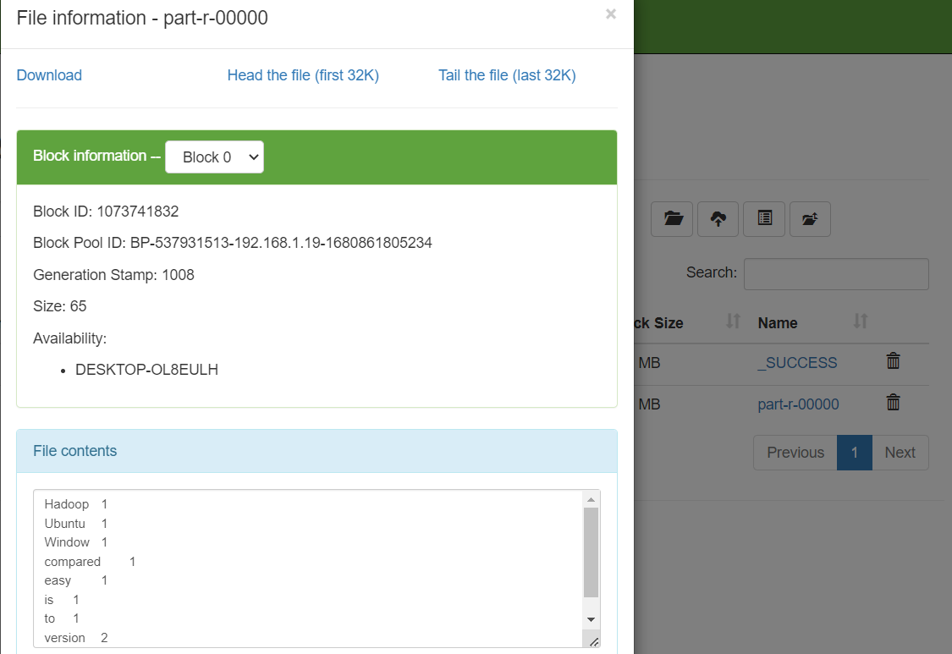

Alternatively, you may type the following command on CMD window as:

C:\> hadoop dfs -cat /output_dir/*

You can get the following output

**PRACTICAL 3**

**Aim:**

Implement an application that stores big data in Hbase / MongoDB and manipulate it using R / Python

**Requirements**

a. PyMongo

b. Mongo Database

**Step A: Install Mongo database**

Step 1) Go to (https://www.mongodb.com/download-center/community) and Download

MongoDB Community Server. We will install the 64-bit version for Windows.

Step 2) Once download is complete open the msi file. Click Next in the start up screen

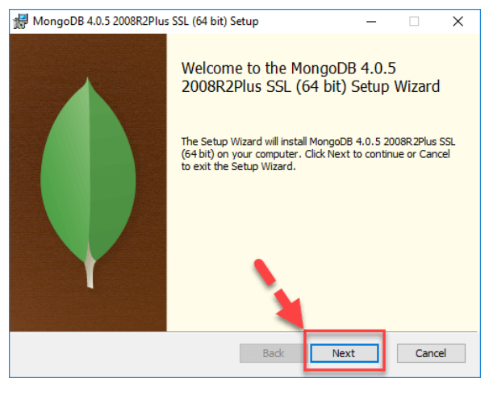

Step 3)

1. Accept the End-User License Agreement

2. Click Next

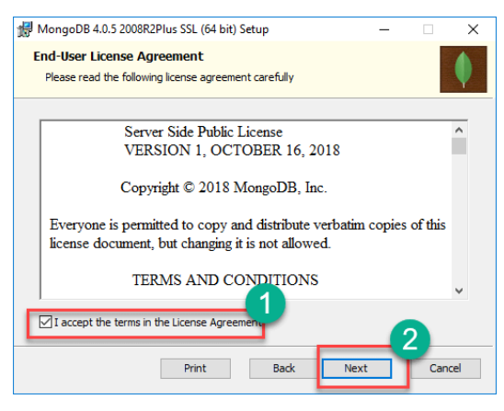

Step 4) Click on the "complete" button to install all of the components. The custom

option can be used to install selective components or if you want to change the location

of the installation.

Step 5)

1. Select “Run service as Network Service user”. make a note of the data directory,

we”ll need this later.

2. Click Next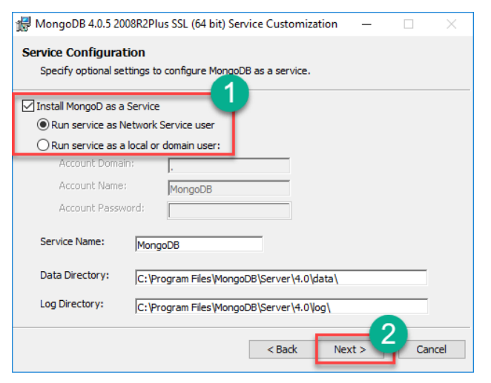

Step 6) Click on the Install button to start the installation.

Step 7) Installation begins. Click Next once completed.

Step 8) Click on the Finish button to complete the installation.

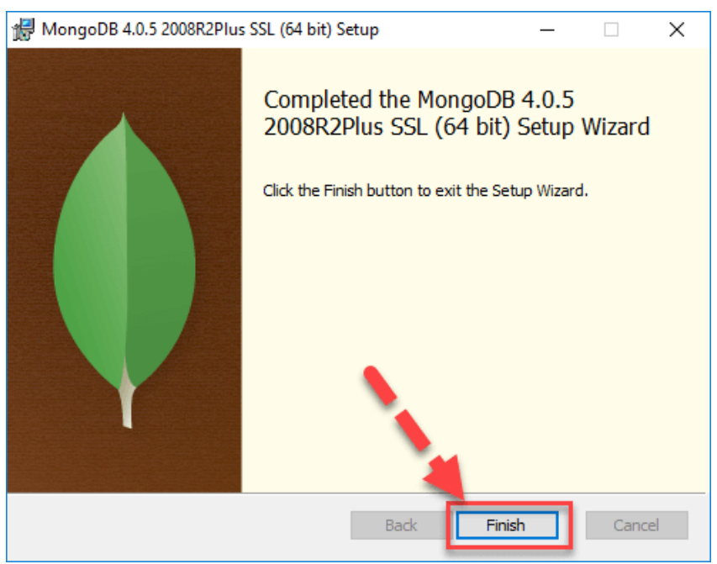

**Test Mongodb**

**Step 1**) Go to " C:\Program Files\MongoDB\Server\4.0\bin" and double click on **mongo.exe.** Alternatively, you can also click on the MongoDB desktop icon.

* **Create the directory where MongoDB will store its files.**

Open command prompt window and apply following commands

C:\users\admin> cd\

C:\>md data\db

**Step 2) Execute mongodb**

Open another command prompt window.

C:\> cd C:\Program Files\MongoDB\Server\4.0\bin

C:\Program Files\MongoDB\Server\4.0\bin> mongod

*In case if it gives an error then run the following command:*

*C:\Program Files\MongoDB\Server\4.0\bin> mongod –repair*

**Step 3) Connect to MongoDB using the Mongo shell**

Let the MongoDB daemon to run.

Open another command prompt window and run the following commands:

C:\users\admin> cd C:\Program Files\MongoDB\Server\4.0\bin

C:\Program Files\MongoDB\Server\4.0\bin>mongo

**Step 4) Install PyMongo**

Open another command prompt window and run the following commands:

Check the python version on your desktop / laptop and copy that path from window explorer

C:\users\admin>cd C:\Program Files\Python311\Scripts

C:\Program Files\<Python38>\Scripts > python -m pip install pymongo

Note: # **-m** option is for <module-name>

Now you have downloaded and installed a mongoDB driver.

**Step 5) Test PyMongo**

Run the following command from python command prompt

import pymongo

Now, either create a file in Python IDLE or run all commands one by one in sequence on Python cell

**Program 1: Creating a Database: create_dp.py**

import pymongo

myclient = pymongo.MongoClient("mongodb://localhost:27017/")

mydb = myclient["mybigdata"]

print(myclient.list_database_names())



**Progam 2: Creating a Collection:  create_collection.py**

import pymongo

myclient = pymongo.MongoClient("mongodb://localhost:27017/")

mydb = myclient["mybigdata"]

mycol=mydb["student"]

print(mydb.list_collection_names())



**Progam 3: Insert into Collection:  insert_into_collection.py**

import pymongo

myclient = pymongo.MongoClient("mongodb://localhost:27017/")

mydb = myclient["mybigdata"]

mycol=mydb["student"]

mydict={"name":"Beena", "address":"Mumbai"}

x=mycol.insert_one(mydict) # insert_one(containing the name(s) and value(s) of each field

**Program 4: Insert Multiple data into Collection: insert_many.py**

import pymongo

myclient = pymongo.MongoClient("mongodb://localhost:27017/")

mydb = myclient["mybigdata"]

mycol=mydb["student"]

mylist=[{"name":"Khyati", "address":"Mumbai"}, {"name":"Kruti", "address":"Mumbai"},

{"name":"Nidhi", "address":"Pune"}, {"name":"Komal", "address":"Pune"},]

x=mycol.insert_many(mylist)

**Step 6) Test in Mongodb to check database and data inserted in collection**

a. If you want to check your database list, use the command show dbs in mongo

command prompt

> show dbs

b. If you want to use a database with name mybigdata, then use database

statement would be as follow:

> use mybigdata



c. If you want to check collection in mongodb use the command show collections

> show collections



d. If you want to display the first row from collection: db.collection_name.find()

> db.student.findOne()

e. If you want to display all the data from collection: db.collection_name.find()

> db.student.find()

f. count number of rows in a collection

> db.student.count()



**Site for R packages documentation:**

<https://cran.r-project.org/web/packages/available_packages_by_name.html>

**PRACTICAL 4**

**NOTE : OUR AIM [**AIM: Implement the program in PRACTICAL 4 using pig]

(Provided PRACTICAL by sir)

**Aim :** Write a Pig Script for solving counting problems.

**Steps :**

cat> /home/cloudera/input.csv

cat /home/cloudera/input.csv

pig -x local

lines = load '/home/cloudera/input.csv' as (line:chararray);

words = foreach lines GENERATE FLATTEN(TOKENIZE(line)) as woed;

grouped = GROUP words by woed;

wordcount = foreach grouped GENERATE group, COUNT(words);

dump wordcount;

**PRACTICAL 5**

**NOTE(out aim: Configure the Hive and implement the application in Hive)**

**Aim**: Install Hive and use Hive Create and store structured databases.

**Steps**:

cat > /home/cloudera/employee.txt

1~Sachine~Pune~Product Engineering~100000~Big Data

2~Gaurav~Banglore~Sales~90000~CRM

3~Manish~Chennai~Recruiter~125000~HR

4~Bhushan~Hyderabad~Developer~50000~BFSI

cat /home/cloudera/employee.txt

sudo -u hdfs hadoop fs -put /home/cloudera/employee.txt /inputdirectroy

hdfs dfs -ls /

hdfs dfs -ls /inputdirectory

hadoop fs -cat /inputdirectory/employee.txt

hive

show databases;

create database organization;

show databases;

use organization;

show tables;

hive> create table employee(

> id int,

> name string,

> city string,

> department string,

> salary int,

> domain string)

> row format delimited

> fields terminated by '~';

show tables;

select * from employee;

show tables;

load data inpath '/inputdirectory/employee.txt' overwrite into table employee;

show tables;

select * from employee;

**PRACTICAL 6**

PRACTICAL 6A

AIM: Implement decision tree classification techniques

**Aim:**

a) Implement Decision Tree classification technique using Social_Network_Ads.csv dataset.

**Code:**

# Decision Tree Classification

# Importing the dataset

dataset = read.csv("C:\\2022-23\\BDA PRACTICAL 2023\\Social_Network_Ads.csv")

#print(dataset)

dataset = dataset[3:5] # columns 3 4 ad 5

print(dataset)

# Encoding the target feature as factor(just like a vector having levels

# levels to convey that only two possible values for purchased - 0 & 1

dataset$Purchased = factor(dataset$Purchased, levels = c(0, 1))

print (dataset$Purchased)

# Splitting the dataset into the Training set and Test set

install.packages('caTools')

library(caTools)

set.seed(123)

#split = sample.split(dataset$Purchased, SplitRatio = 0.75)

split = sample.split(dataset$Purchased, SplitRatio = 0.75)

training_set = subset(dataset, split == TRUE)

test_set = subset(dataset, split == FALSE)

# Feature Scaling - scale() method centers and/or scales the columns of a numeric matrix.

training_set[-3] = scale(training_set[-3]) # scaling first 2 columns, don't consider 3rd column

test_set[-3] = scale(test_set[-3])

#print(test_set[-3])

# Fitting Decision Tree Classification to the Training set

install.packages('rpart')

library(rpart) # for partitioning tree

install.packages('rpart.plot')

library(rpart.plot)

classifier = rpart(formula = Purchased ~ .,data = training_set)

# Predicting the Test set results

y_pred = predict(classifier, newdata = test_set[-3], type = 'class')

print(y_pred)

# Making the Confusion Matrix

cm = table(test_set[, 3], y_pred)

print(cm)

y_grid = predict(classifier, newdata = grid_set, type = 'class')

# Plotting the tree

#extra=106 class model with a binary response

#extra=104 class model with a response having more than two levels

rpart.plot(classifier, extra = 106)

**Output:**

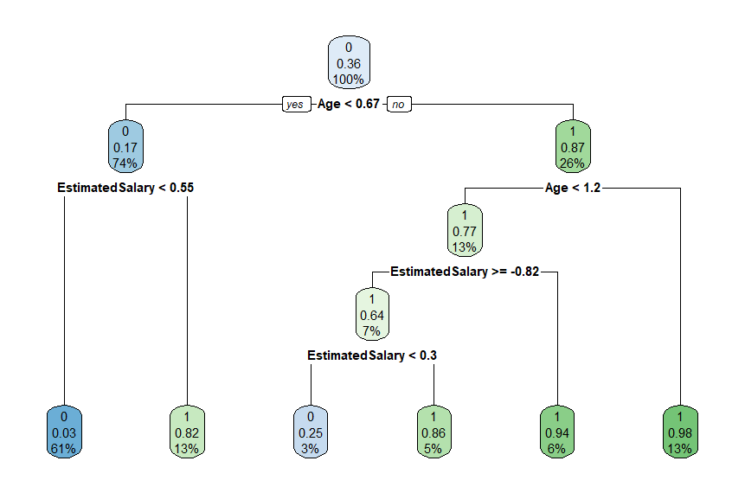

**PRACTICAL 6B**

SVM Classification

**Aim:**

b) Implement SVM Classification technique using Social_Network_Ads.csv dataset. Evaluate the performance of classifier.

**Code:**

# Support Vector Machine (SVM)

# Importing the dataset

dataset = read.csv('C:\\2022-23\\BDA PRACTICAL 2023\\Social_Network_Ads.csv')

dataset = dataset[3:5]

print(dataset)

print(dataset$Purchased)

# Splitting the dataset into the Training set and Test set

install.packages('caTools')

library(caTools)

set.seed(123)

split = sample.split(dataset$Purchased, SplitRatio = 0.75)

training_set = subset(dataset, split == TRUE)

print(training_set)

test_set = subset(dataset, split == FALSE)

print(test_set)

# Feature Scaling

training_set[-3] = scale(training_set[-3]) # [-3] means 3rd index will be dropped

test_set[-3] = scale(test_set[-3])

print(training_set[-3])

print (test_set[-3])

# Fitting SVM to the Training set

install.packages('e1071')

library(e1071)

classifier = svm(formula = Purchased ~ .,

data = training_set,

type = 'C-classification',

kernel = 'linear')

print (classifier)

# Predicting the Test set results

y_pred = predict(classifier, newdata = test_set[-3])

print(y_pred)

# Making the Confusion Matrix

cm = table(test_set[, 3], y_pred)

print (cm)

**Output:**

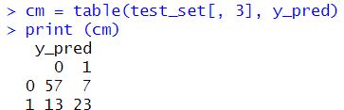

**PRACTICAL 7**

**PRACTICAL 7A**

Logistic Regression

**Aim:**

a) Import data from web storage – binary.csv. Name the dataset and do Logistic Regression to find out relation between variables that are affecting the admission of a student in an institute based on his or her GRE score, GPA obtained and rank of the student. Also check the model is fit or not.

**Code:**

#fetch the data

college <- read.csv("https://raw.githubusercontent.com/csquared/udacity-dlnd/master/nn/binary.csv")

head(college)

nrow(college)

install.packages("caTools") # For Logistic regression

library(caTools)

split <- sample.split(college, SplitRatio = 0.75)

split

training_reg <- subset(college, split == "TRUE")

test_reg <- subset(college, split == "FALSE")

# Training model

fit_logistic_model <- glm(admit ~ .,

data = training_reg,

family = "binomial")

# Predict test data based on model

predict_reg <- predict(fit_logistic_model,

test_reg, type = "response")

predict_reg

cdplot(as.factor(admit)~ gpa, data=college)

cdplot(as.factor(admit)~ gre, data=college)

cdplot(as.factor(admit)~ rank, data=college)

# Changing probabilities

predict_reg <- ifelse(predict_reg >0.5, 1, 0)

predict_reg

# Evaluating model accuracy

# using confusion matrix

table(test_reg$admit, predict_reg)

**Output:**

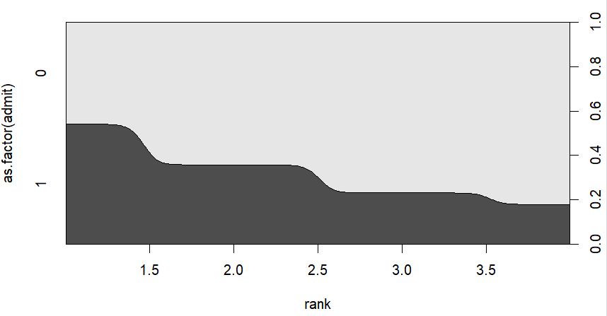

**PRACTICAL 7B**

Multiple Regression Model

**Aim:**

b) Apply multiple regressions, if data have a continuous independent variable. Apply on above dataset – binary.csv.

**Code:**

#fetch the data

college <- read.csv("https://raw.githubusercontent.com/csquared/udacity-dlnd/master/nn/binary.csv")

head(college)

nrow(college)

install.packages("caTools") # For Logistic regression

library(caTools)

split <- sample.split(college, SplitRatio = 0.75)

split

training_reg <- subset(college, split == "TRUE")

test_reg <- subset(college, split == "FALSE")

# Training model

fit_MRegressor_model <- lm(formula = admit ~ gre+gpa+rank,

data = training_reg)

# Predict test data based on model

predict_reg <- predict(fit_MRegressor_model,

newdata = test_reg)

predict_reg

cdplot(as.factor(admit)~ gpa, data=college)

cdplot(as.factor(admit)~ gre, data=college)

cdplot(as.factor(admit)~ rank, data=college)

**Output:**

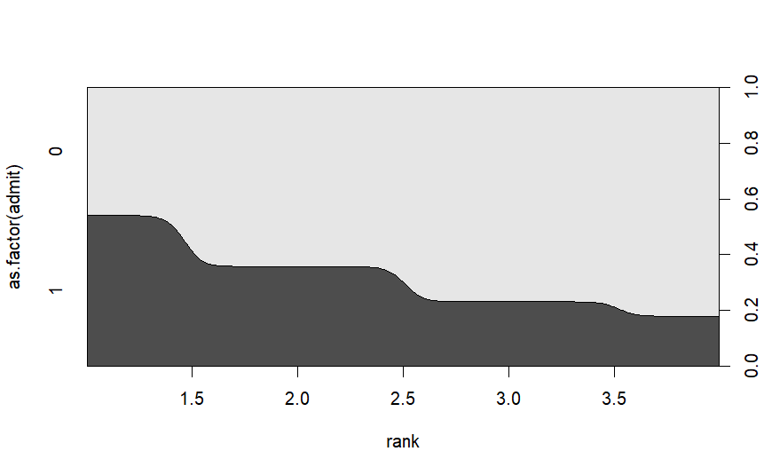

**PRACTICAL 8**

**PRACTICAL 8A**

Classification Model

Naïve Bayes Classification

**Aim:**

a) Implement Naïve Bayes Classification technique using Social_Network_Ads.csv dataset. Evaluate the performance of classifier.

**Code:**

# Naive Bayes

# Importing the dataset

dataset = read.csv('C:\\2022-23\\BDA PRACTICAL 2023\\Social_Network_Ads.csv')

dataset = dataset[3:5]

# Encoding the target feature as factor

dataset$Purchased = factor(dataset$Purchased, levels = c(0, 1))

# Splitting the dataset into the Training set and Test set

#install.packages('caTools')

library(caTools)

set.seed(123)

split = sample.split(dataset$Purchased, SplitRatio = 0.75)

training_set = subset(dataset, split == TRUE)

test_set = subset(dataset, split == FALSE)

# Feature Scaling

training_set[-3] = scale(training_set[-3])

test_set[-3] = scale(test_set[-3])

# Fitting Naive Bayes to the Training set

install.packages('e1071')

library(e1071)

classifier = naiveBayes(x = training_set[-3],

y = training_set$Purchased)

# Predicting the Test set results

y_pred = predict(classifier, newdata = test_set[-3])

# Making the Confusion Matrix

cm = table(test_set[, 3], y_pred)

print(cm)

**Output:**

**PRACTICAL 8B**

K-Means Clustering

**Aim:**

a) Clustering algorithms for unsupervised classification. Read a datafile Mall_Customers.csv and apply k-means clustering. Plot the cluster data using R visualizations.

**Code:**

# K-Means Clustering

# Importing the dataset

dataset = read.csv('C:\\2022-23\\BDA PRACTICAL 2023\\Mall_Customers.csv')

head(dataset)

dataset = dataset[4:5]

head(dataset)

wcss = vector()

for (i in 1:10) wcss[i] = sum(kmeans(dataset, i)$withinss)

plot(1:10,

wcss,

type = 'b',

main = paste('The Elbow Method'),

xlab = 'Number of clusters',

ylab = 'WSS')

# Fitting K-Means to the dataset with no of clusters = 5

kmeans = kmeans(x = dataset, centers = 5)

y_kmeans = kmeans$cluster

# Visualising the clusters

library(cluster)

clusplot(dataset,

y_kmeans,

lines = 0,

shade = TRUE,

color = TRUE,

labels = 2,

main = paste('Clusters of customers'),

xlab = 'Annual Income',

ylab = 'Spending Score')

**Output:**

